Cambridge South Hockey Club

Come and play for the friendliest hockey club in Cambridge, with Saturday league sides for men and ladies, and mixed friendly matches on Sundays.

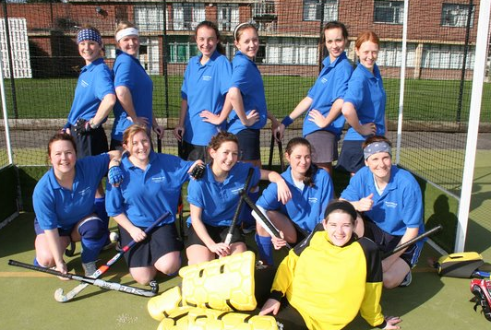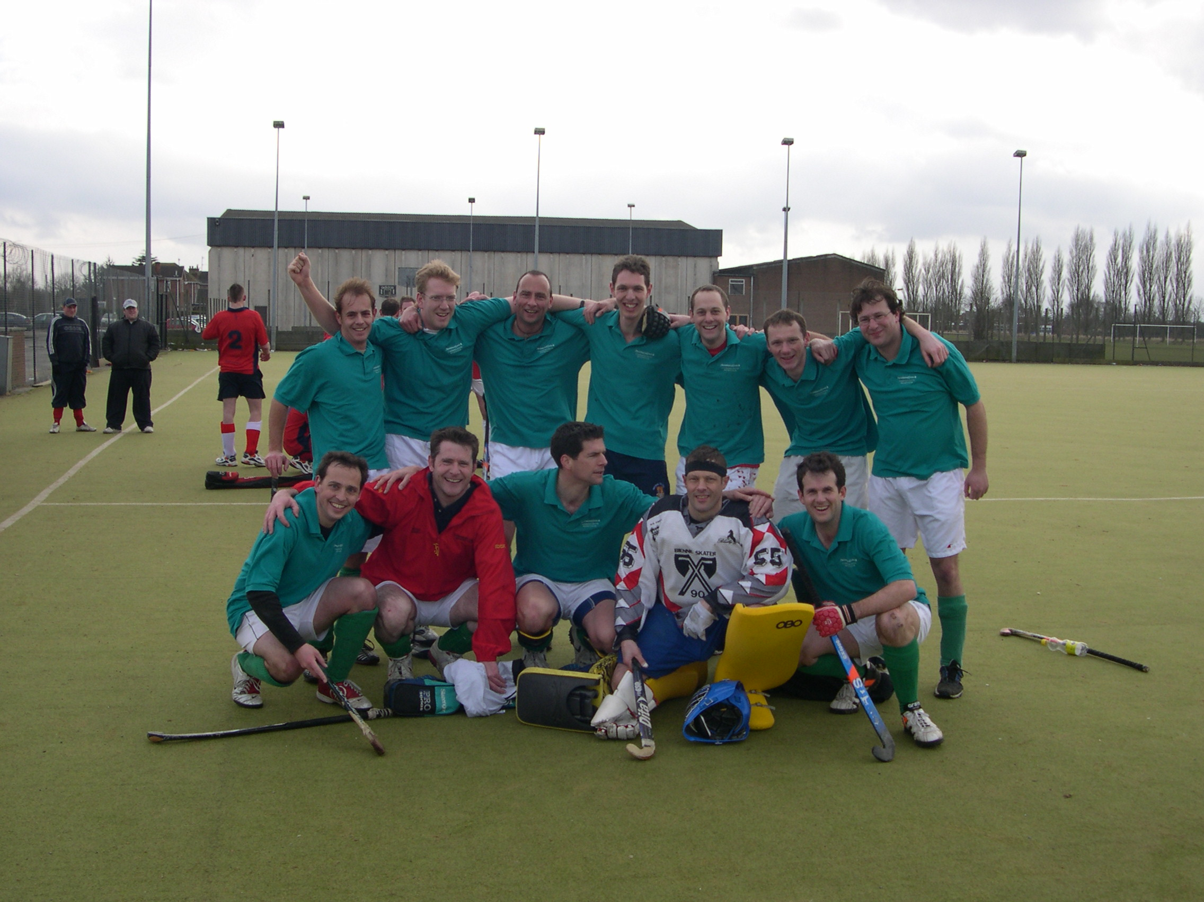

We have 4 mens’ and 2 ladies’ league teams, so there is something for everyone – whether you are an experienced player or a beginner, come and have a go.

Join us for training on Tuesday evenings at the Leys School Astroturf pitch on Trumpington Road 7.40 - 9 pm. Just turn up!


If you do have any questions please contact John on benedikz82@yahoo.co.uk or see our website: http://www.cambridgesouthhockeyclub.co.uk/
Cambridge South HC are sponsored by

